

February 2026

Nexa Asset Acquisitions (www.nexaassetacquisitions.com) is well-placed to benefit from what is gearing up to be the largest Tax Refund Season in history. Our focus on purchasing deeply discounted accounts receivable enables us to work with consumers to repair their credit at a time when they have additional money in their pockets.

Tax refunds in 2026 are expected to provide a significant short-term boost to the U.S. economy, acting as a massive fiscal injection. This is due to the One Big Beautiful Bill Act (OBBBA).

Most federal tax refunds are issued within 21 days of electronic filing with direct deposit, or about 6-8 weeks for paper returns. For the 2026 season, early filers may receive funds by mid-February. The average refund is estimated to be over $4,000 this year and even higher for those benefiting from the New & Expanded Credits:
- Child Tax Credit: Increased to $2,200 per child.
- Standard Deduction: Boosted for inflation and legislation, rising to $31,500 for married couples.
- New Deductions: New tax breaks were added for tips, overtime pay, American-made car loan interest, and a special $6,000 deduction for seniors.
- SALT Cap Increase: The state and local tax deduction cap was raised from $10,000 to $40,000 for eligible households.
Americans have more money to spend in 2026 due to a combination of major tax policy changes, rising real wages, and record household wealth, surpassing $180 trillion due to the rising stock market and stable house prices.

Also, energy prices have dropped significantly, with gas prices falling below $3 per gallon in 43 states and below $2 in 19 states, freeing up more monthly disposable income for other expenses.

The Nexa Process: Nexa manages investor returns through a strategy of fine-tuning settlement and payment plan strategies based on a consumer’s ability to pay.
- 100% of investor capital is estimated to be returned by Month 15.
  - Investors receive net cashflows monthly starting in Month 2.
- Total return estimated at 167% by the end of Month 36.

As shown in the Portfolio Trending Chart below, all portfolios are on track with our original targets of returning capital in 15 months and then producing a profit of 67% to 110% by the 36th month:

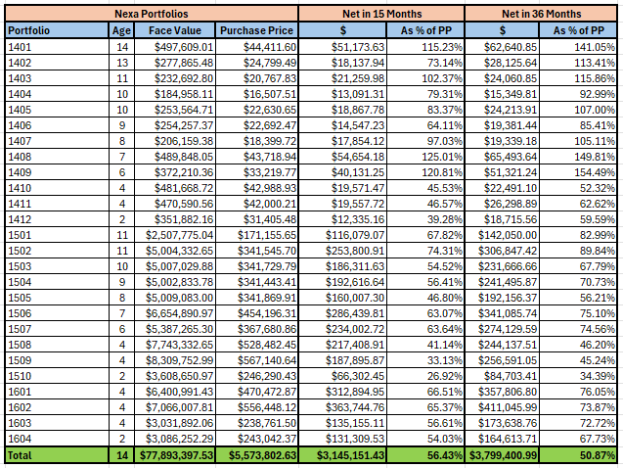

Nexa is a fully licensed Debt Buyer, in compliance with all FDCPA, CFPB and state regulations. Its AI predictive model pinpoints consumer response in 92% of contact points.

We look forward to explaining The Nexa Process and discussing how this program may benefit your own portfolio.

Kind regards,

Peter Bennett
CEO

DISCLAIMER: Past performance may not be indicative of future results. Therefore, no current or prospective client should assume that future performance of any specific investment or investment strategy (including the investments and/or investment strategies undertaken by Nexa Portfolio Strategies, LLC) made reference to directly or indirectly by Nexa Portfolio Strategies, LLC in its website, or indirectly via a link to an unaffiliated third-party website, will be profitable or equal the corresponding indicated performance level(s). Different types of investments involve varying degrees of risk, and there can be no assurance that any specific investment will either be suitable or profitable for a client or prospective client’s investment portfolio. Historical performance results for investment indices and/or categories generally do not reflect the deduction of transaction and/or custodial charges, the deduction of an investment management fee, nor the impact of taxes, the incurrence of which would have the effect of decreasing historical performance results.
Please remember that different types of investments involve varying degrees of risk, and there can be no assurance that the future of any specific investment or investment strategy (including those undertaken by Nexa Portfolio Strategies, LLC) will be profitable or equal any historical performance level(s).

